VCS Task

Task Description:

Establish a new directory, populate it with script files, initiate an empty repository on GitHub, convert the local directory into a Git repository, and link it to GitHub for pushing the code into the repository.Perform merge, rebase, stash commands in following github repo.

Overall command history:

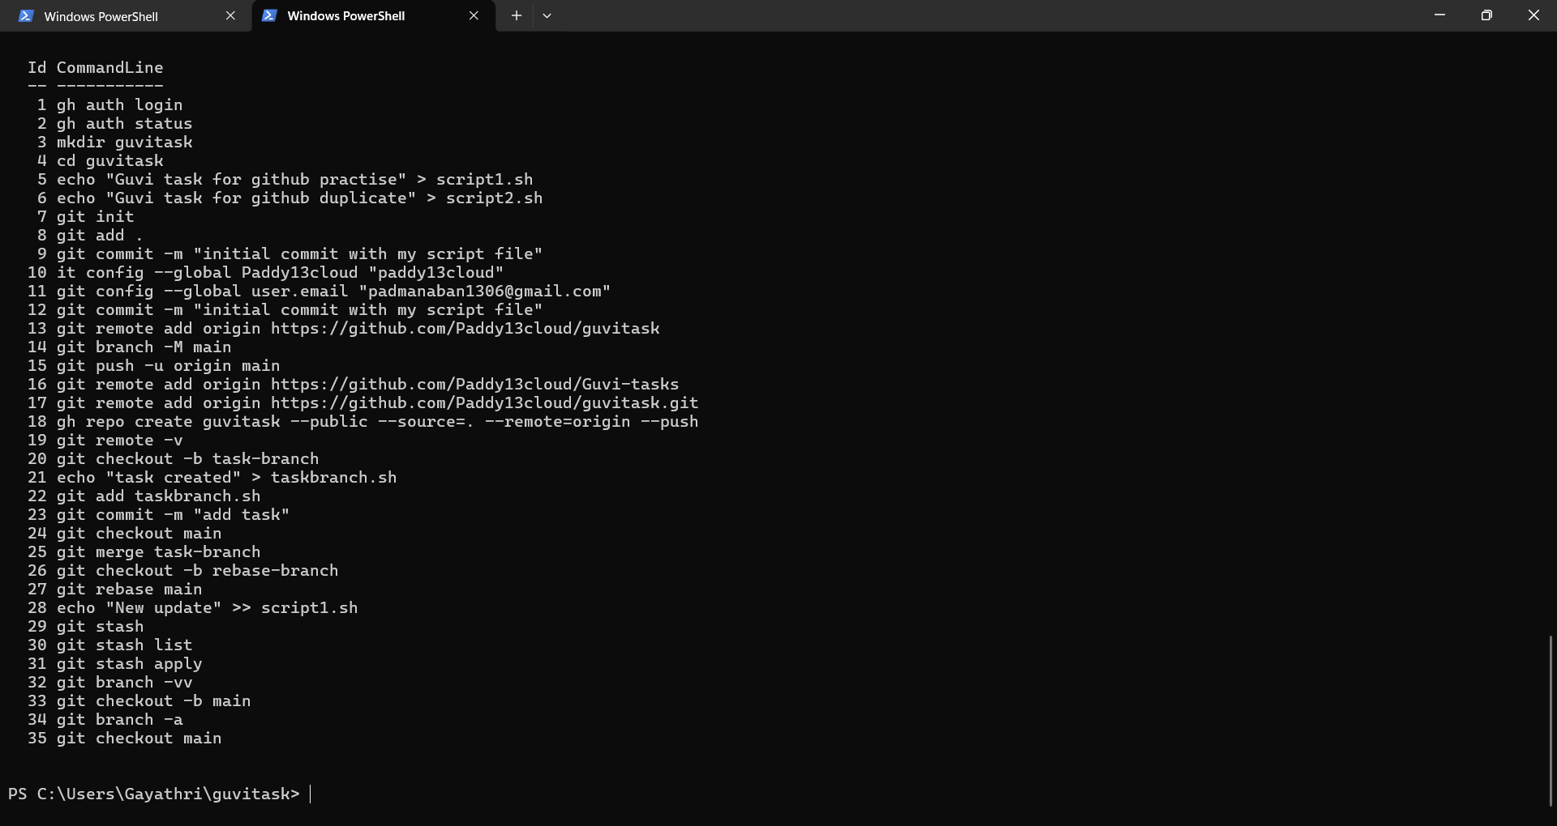

- Establish a new directory, populate it with script files, initiate an empty repository on GitHub

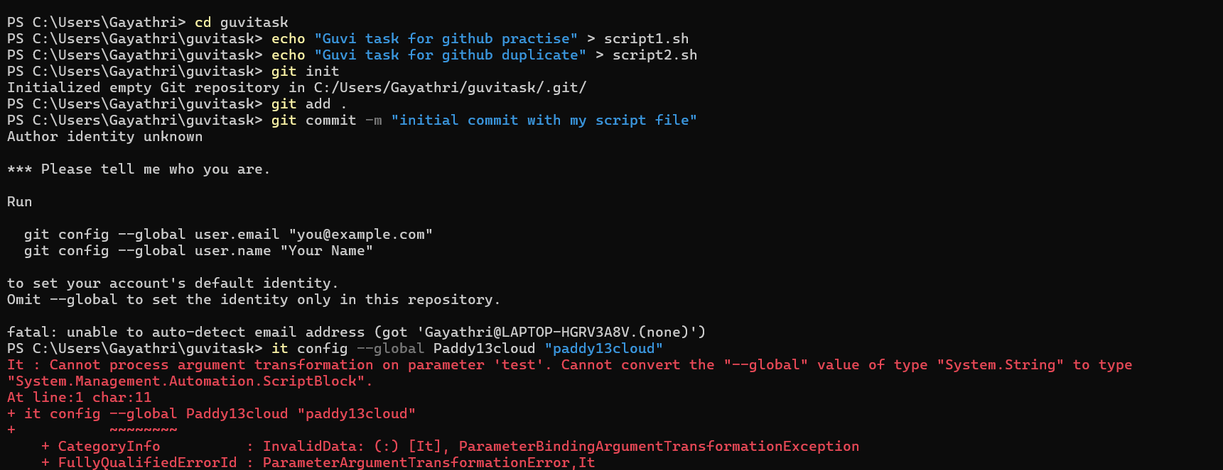

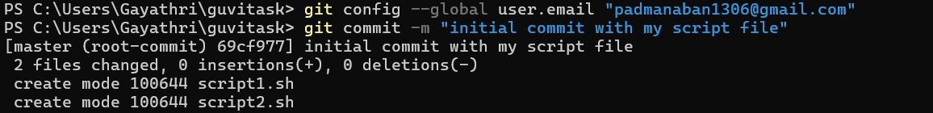

- convert the local directory into a Git repository, and link it to GitHub for pushing the code into the repository

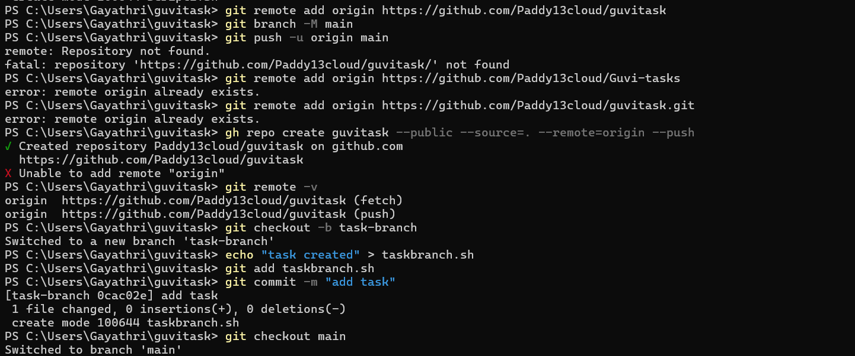

- Perform merge, rebase, stash commands in following github repo.

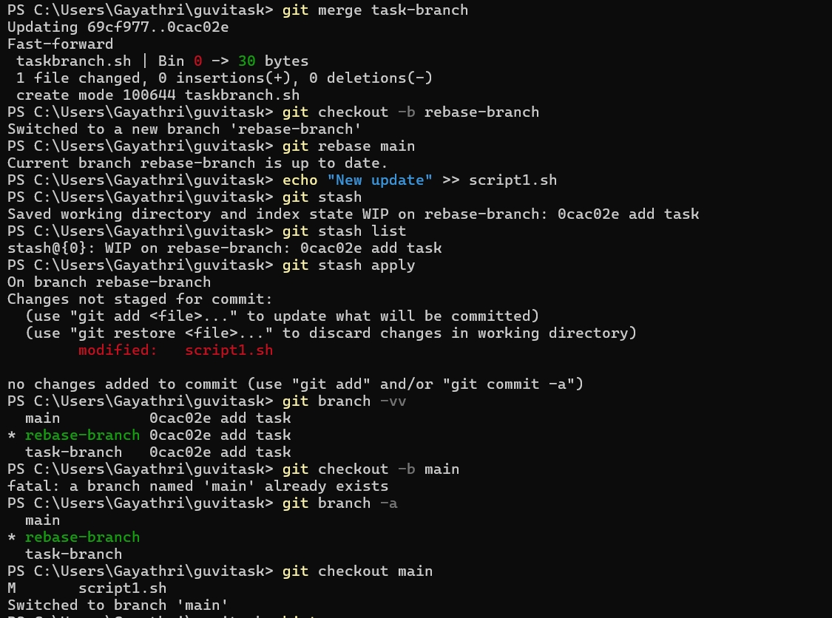

Repository created and verified in git Web url

